

Lab Manual
Subject: Programming of AI

By
Laiba Tanveer 2023-BS-AI-007
Semester 5th
Course Code AI-212
Supervised by Sir Samraiz
The University of Faisalabad
Bachelors of Science in Artificial Intelligence
DEPARTMENT OF COMPUTER SCIENCE

Contents
Lab 1 3
Lab 2 9
Lab 3 14
Lab 4 19
Lab 5 25
Lab 6 31
Lab 7 36
Lab 8 42
Lab 9 47
Lab 10 52

Lab 1
Q1. Banking Transaction Validator with PIN
Simulate a bank ATM.
User enters a 4-digit PIN (check if valid).
Display account balance and ask for withdrawal amount.
If valid → deduct + update balance.
If invalid attempts ≥ 3 → block card.
Use operators to compute service charges (2% per withdrawal).
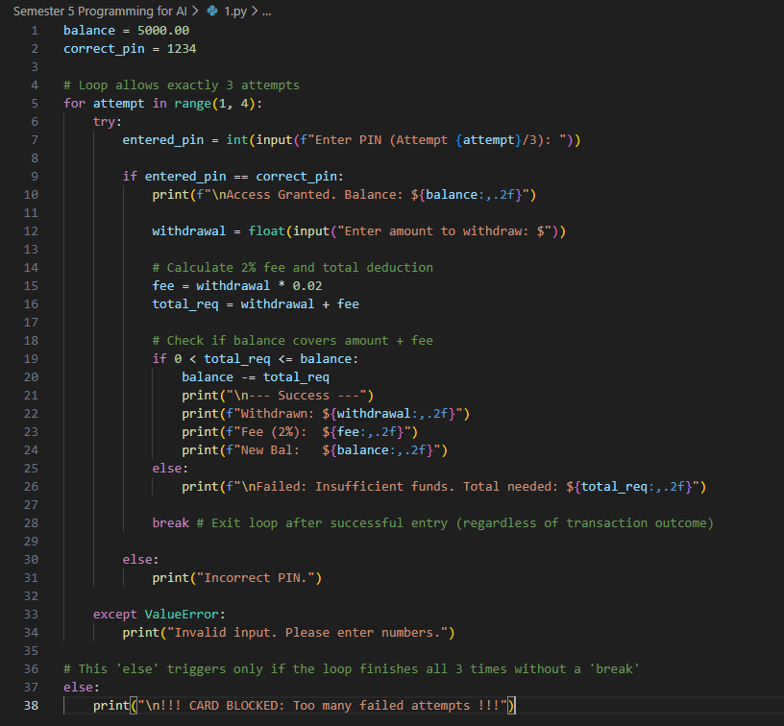
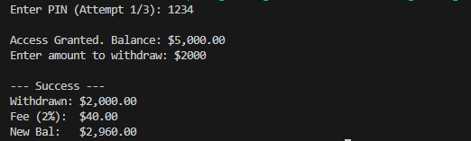
Output:

Q2. Grocery Store Inventory System
Maintain item names, stock, and prices in a dictionary of dictionaries.
User selects items with quantity.
If stock available, deduct from inventory.
Apply discount slabs (10%, 15%, 20%).
Print final bill with tax (5%).
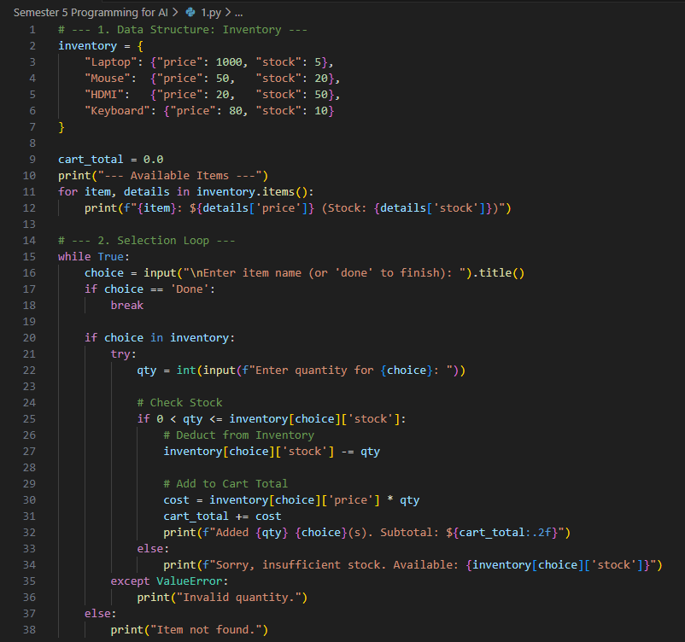
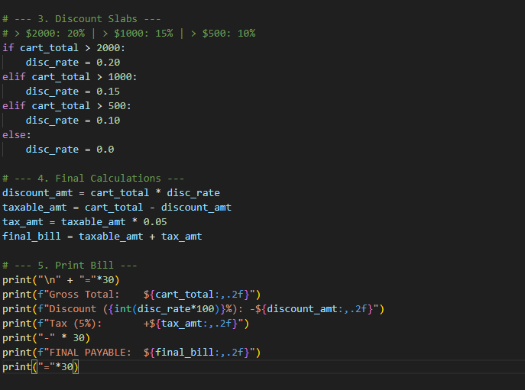
Output:
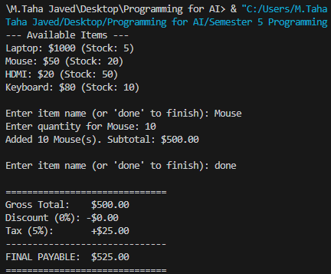
Q3. Student Grading with Subject Weightage
Input marks for 5 subjects where each subject has different weightage (stored in a tuple).
Compute weighted average.
Assign grade (A/B/C/D/Fail).
Also, display whether the student is eligible for scholarship (≥80% weighted).
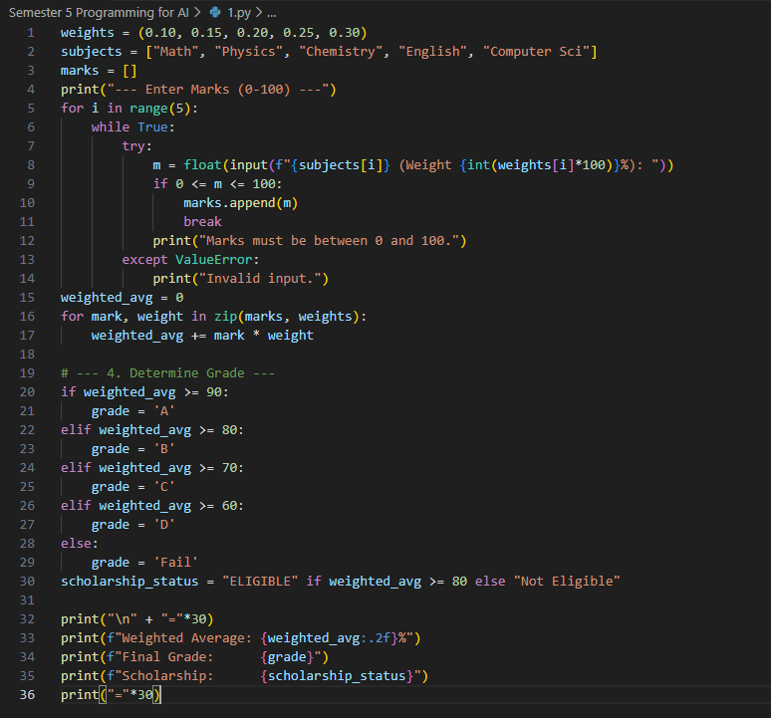
Output:
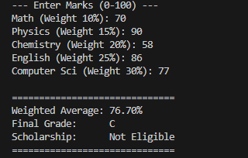
Q4. BMI + Health Recommendation
Extend BMI program:
Take weight, height, and age.
Compute BMI.
Based on BMI and age, give personalized health suggestions (e.g., diet plan for obese, exercise plan for underweight).
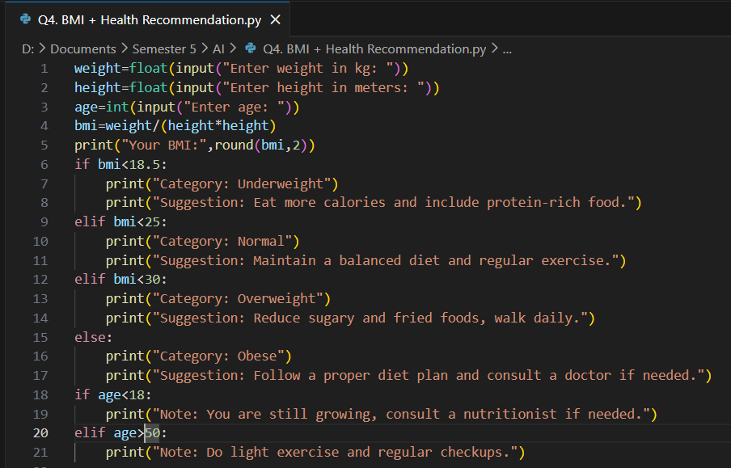
Output:
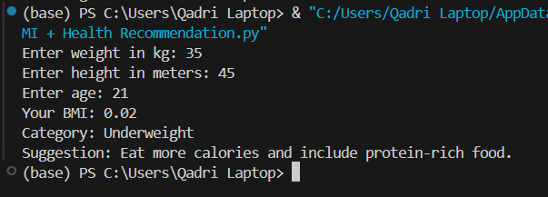
Q5. Telecom Prepaid Recharge System
Maintain call rate/min, SMS rate, and data/MB in a dictionary.
User selects usage (calls, SMS, data).
Deduct accordingly from balance.
If balance < 20% of initial → print recharge reminder.
Apply bonus balance if recharge > 1000.
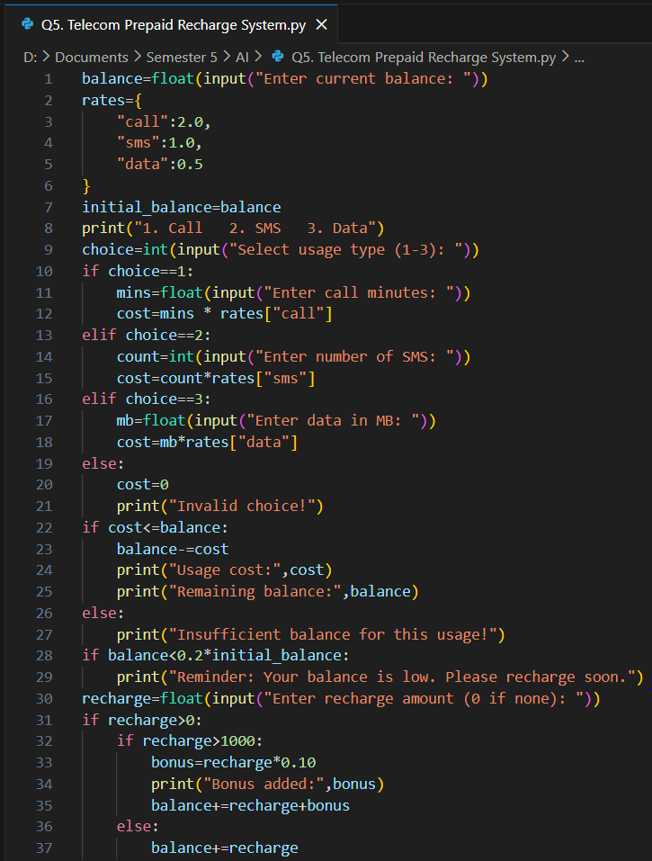
Output:
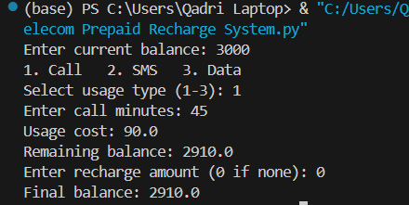

Lab 2
Q6. E-Commerce Discount Engine with Membership Levels
User inputs bill amount + membership type (Regular, Gold, Platinum).
Apply different discount rules (Gold +10%, Platinum +15%).
If bill > 10000, apply additional 5% flat.
Show itemized receipt with tax breakdown.
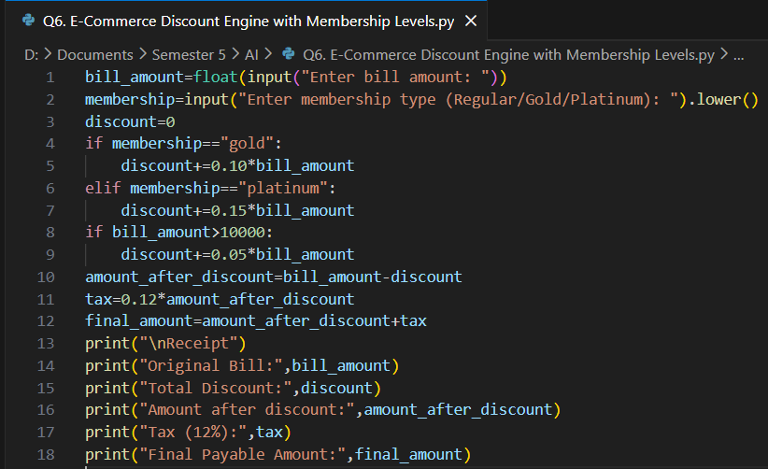
Output:
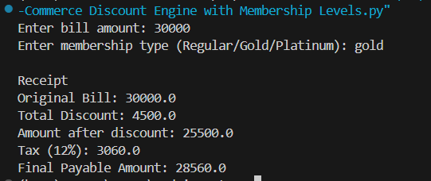
Q7. Hospital Emergency Unit with Multi-Condition Triage
Take patient details: temperature, pulse, oxygen, blood pressure.
Classify into categories: Stable, Observation, Urgent, Critical.
If critical → suggest “Admit in ICU.”
If urgent → suggest “Immediate doctor attention.”
Use nested conditions.
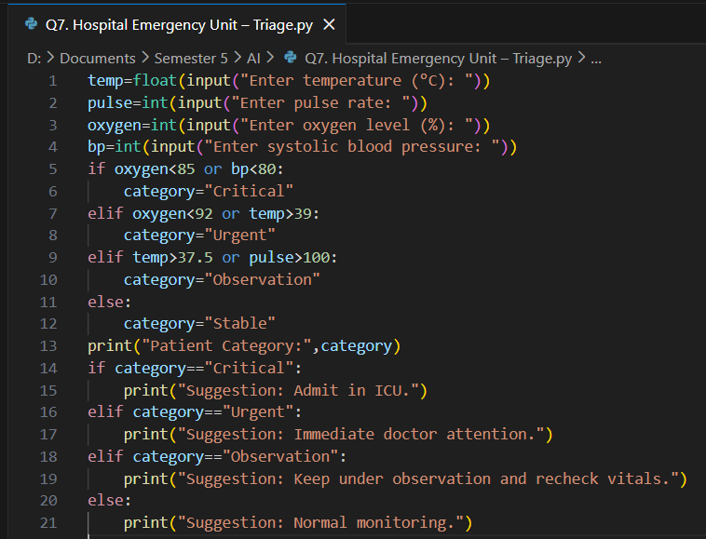
Output:
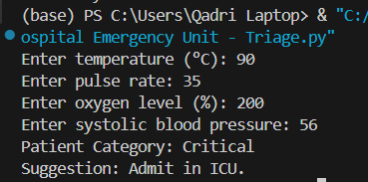
Q8. Online Examination Grader with Negative Marking
Take total marks, obtained marks, and number of wrong answers.
Deduct 0.25 per wrong answer.
Compute percentage.
Assign division + eligibility for scholarship.
If Fail → suggest "Repeat Exam."
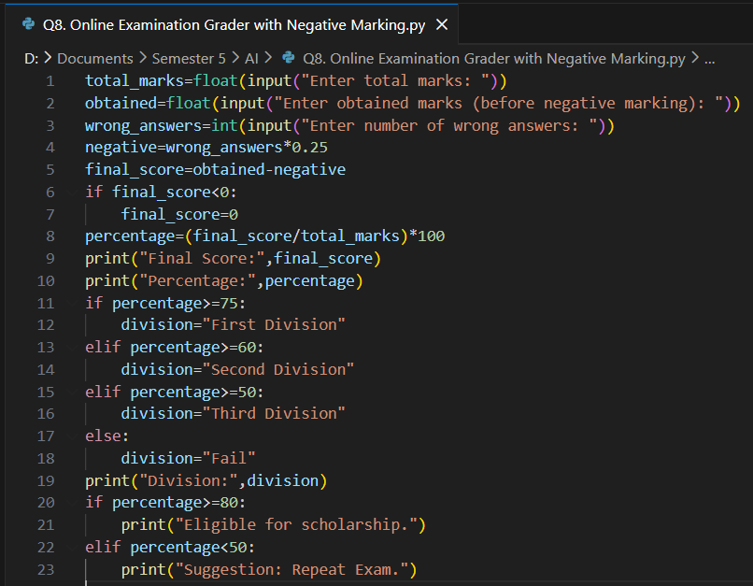
Output:
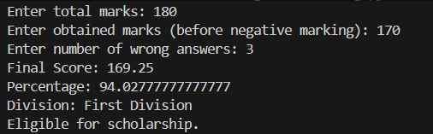
Q9. Movie Ticket Booking with Age & Timing Policy
User inputs: age, showtime, ticket type (Normal/3D/IMAX).
Apply child restrictions (No late-night for <12).
Apply senior citizen discount (30%).
Apply peak hour charges (10%).
Print final ticket price.
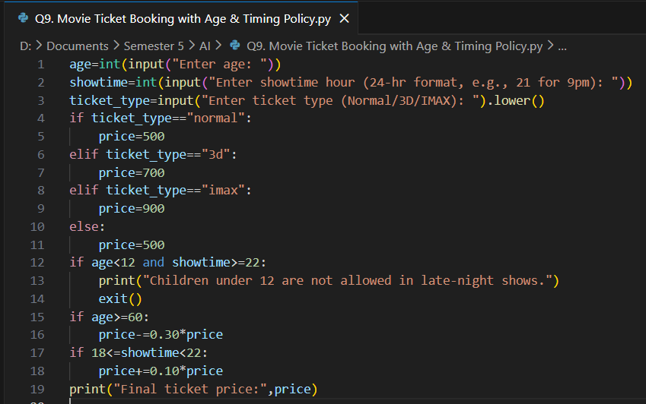
Output:
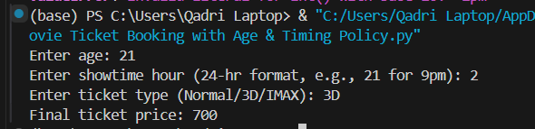
Q10. Weather-based Outfit + Travel Suggestion
Input temperature, weather (Rainy/Sunny/Cold), event type (Casual/Business/Party).
Suggest outfit + accessories.
If Rainy → umbrella; If Cold → gloves.
If event is Business + temperature > 35 → recommend “light formal suit.”
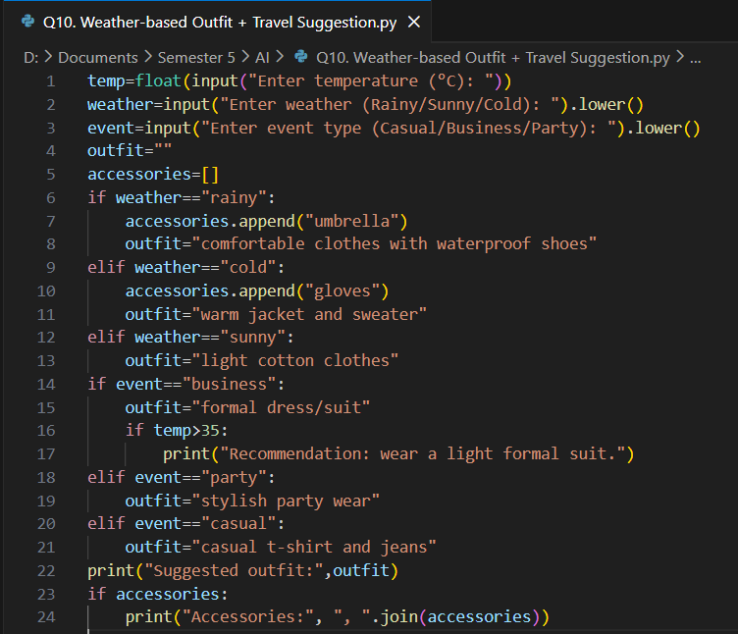
Output:
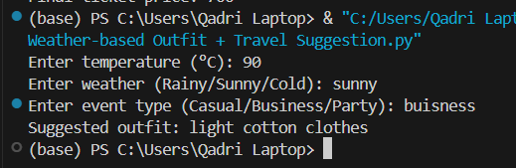

Lab 3
Q11. ATM Withdrawal with Note Counting + Receipt
Take withdrawal amount.
Compute minimum number of notes (1000, 500, 100, 50, 10, 1).
Also compute service charge = 0.5%.
Print receipt with remaining balance after deduction.
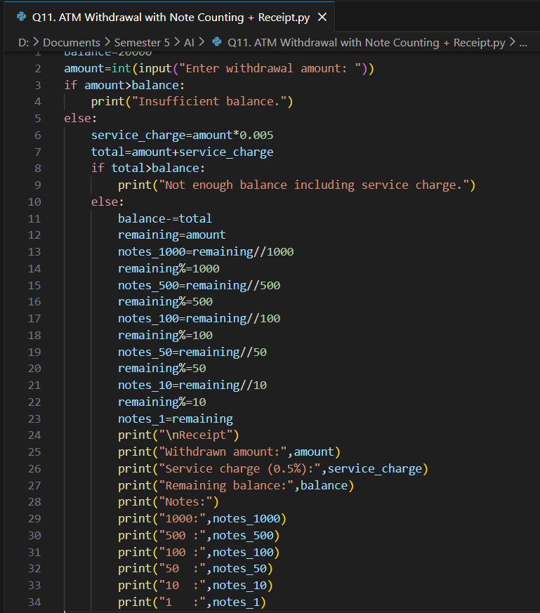
Output:
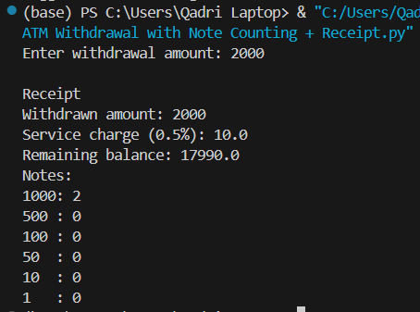
Q12. Library Fine Calculator with Membership Levels
Input days late.
Apply fines (10, 20, 50/day).
If days > 30 → “Membership Cancelled.”
If user is Premium member, reduce fine by 50%.
Print detailed fine slip.
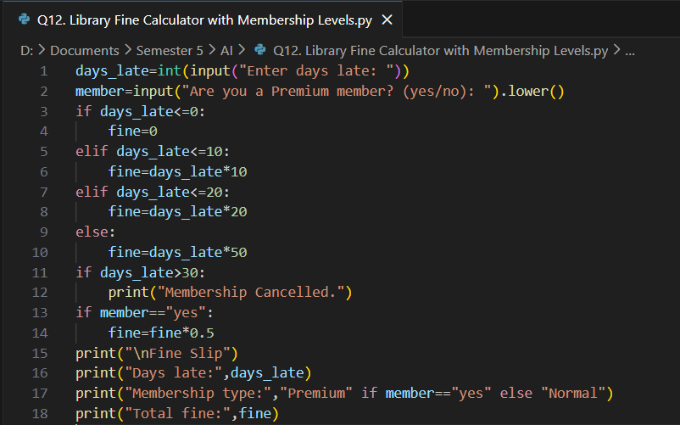
Output:
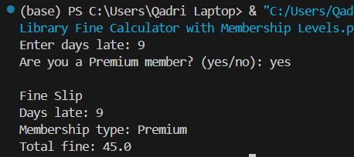
Q13. Sales Analysis Dashboard
Store monthly sales in a list (12 entries).
Print max, min, average.
Print months above average.
Use loop + condition to print “Growth” or “Decline” compared to last month.
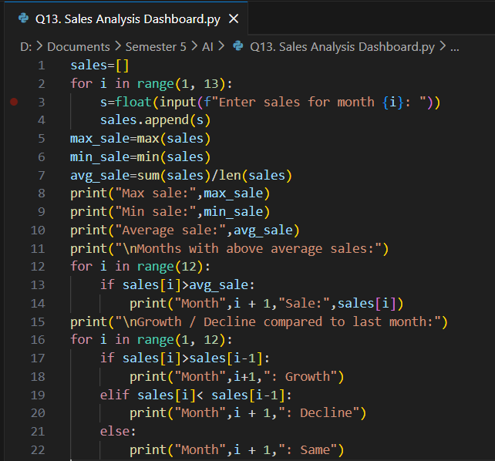
Output:
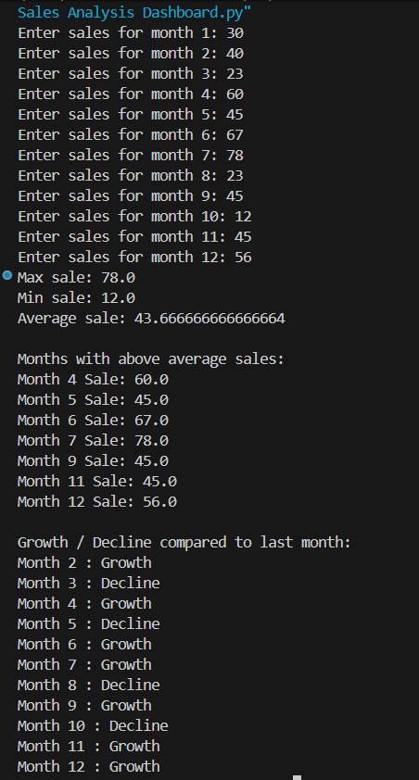
Q14. Multiplication Puzzle with Random Blanks
Generate a multiplication table (1–10).
Randomly replace 3 results with "??".
Ask user to guess values.
Track score. Give performance remark (Excellent/Good/Try Again).
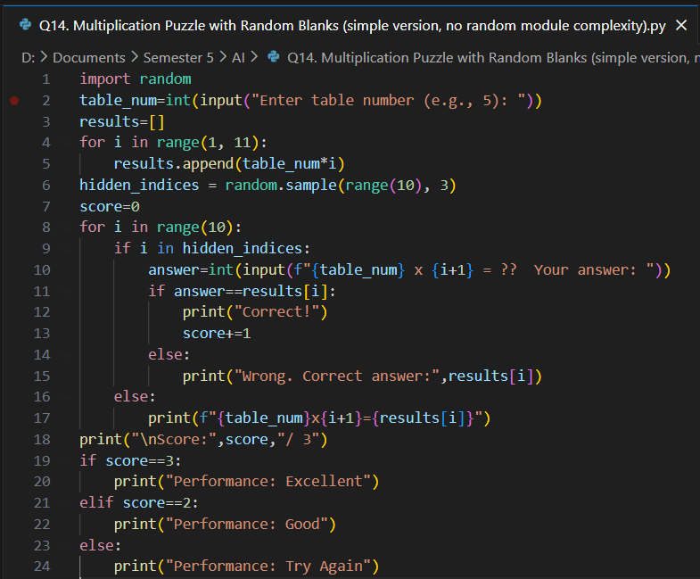
Output:
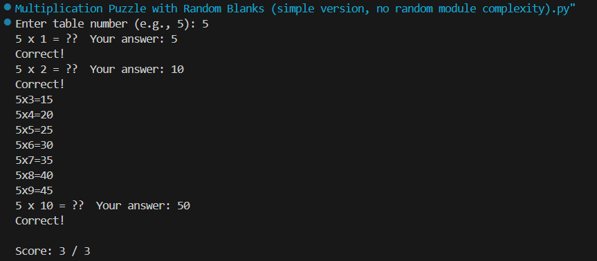
Q15. Password Strength + Re-entry Attempts
Check password rules (length, digit, upper, lower, special).
If weak → ask user to re-enter.
Allow max 3 attempts.
If still weak → “Account Locked.”
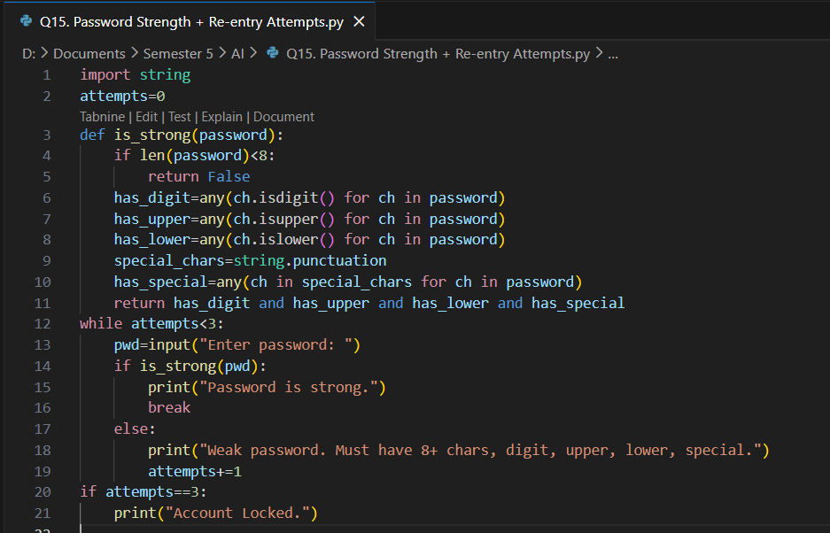
Output:
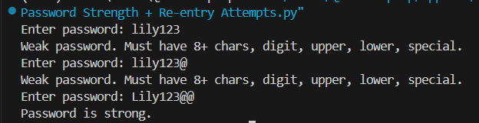

Lab 4
Q16. Electricity Bill with Slabs & Penalty
Function calculate_bill(units, late_payment=False):
Apply slab rates (5/7/10 Rs).
If late_payment → add 15% penalty.
Return bill breakdown.
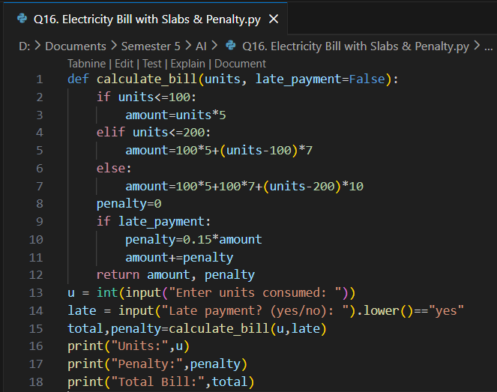
Output:
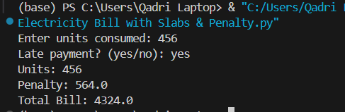
Q17. Cricket Match Predictor with Multiple Conditions
Function predict_score(runs, balls, wickets, overs_left):
Compute strike rate & run rate.
If run rate < 5 and wickets > 6 → “Losing.”
If run rate > 7 and wickets < 5 → “Winning.”
Else → “Balanced.”
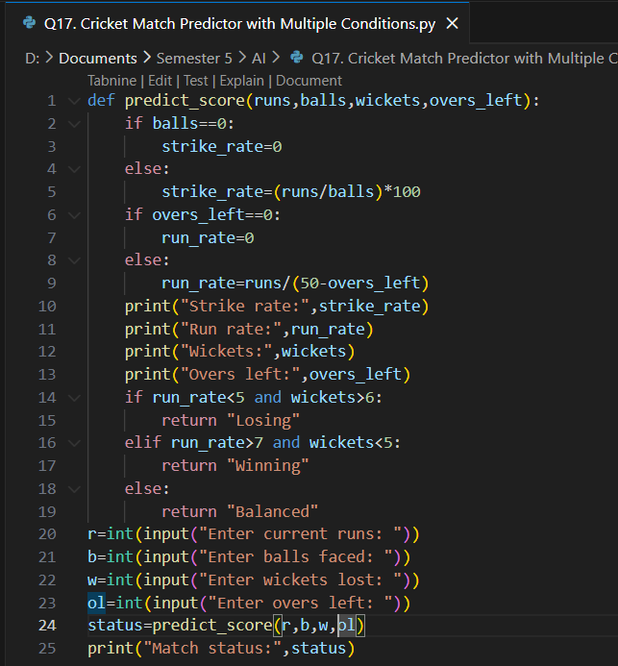
Output:
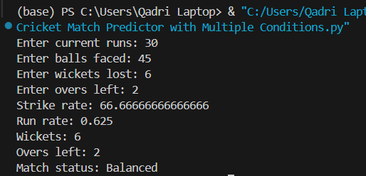
Q18. Hotel Booking with Tax & Discount
Function book_room(type, days, is_member):
Standard: 2000/day, Deluxe: 4000/day, Suite: 6000/day.
If days > 7 → 20% discount.
If member → extra 10% discount.
Add 12% tax.
Return bill slip.
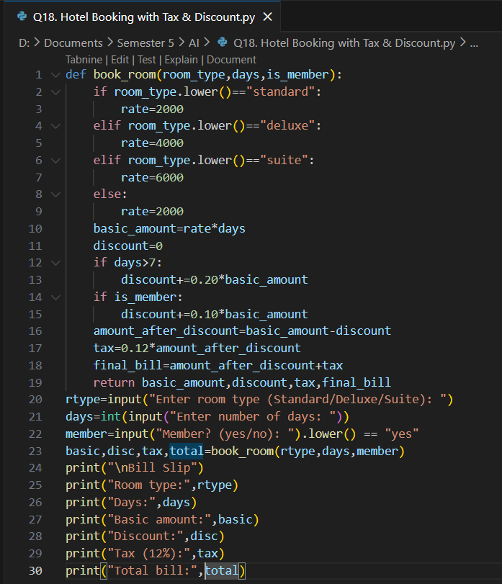
Output:
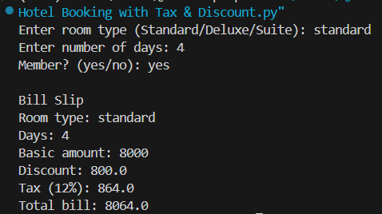
Q19. Flight Fare Calculator with International Tax
Function calculate_fare(distance, class_type, international=False):
Economy: 10/unit, Business: 25/unit, First: 40/unit.
Add fuel surcharge 500.
If international → add 18% tax.
If booking in advance (>30 days) → 10% discount.
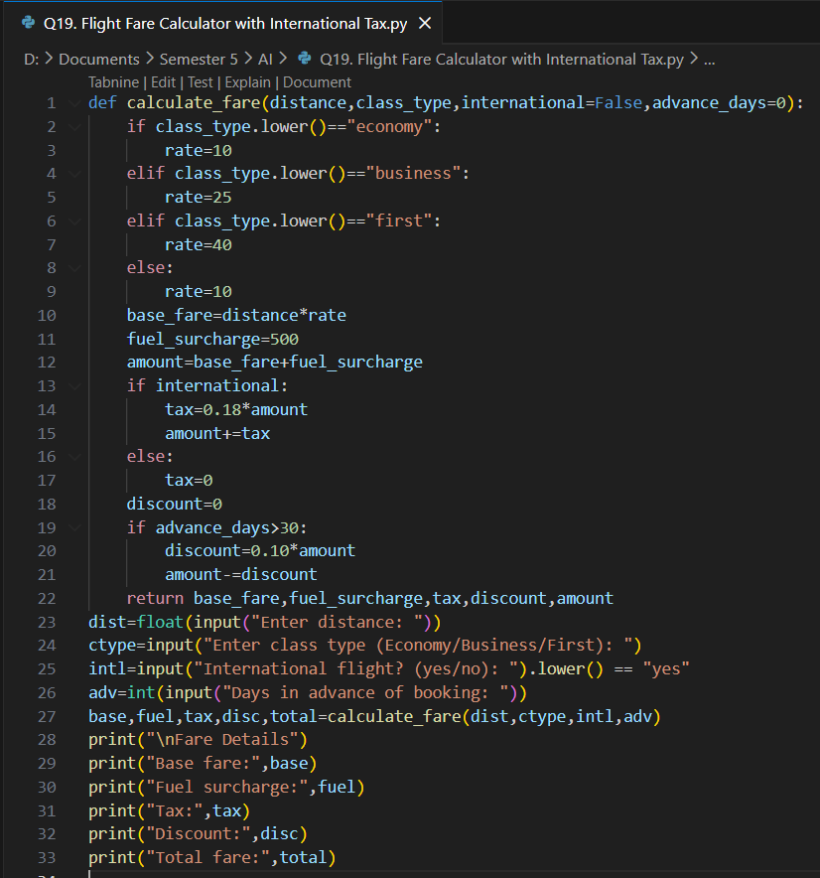
Output:
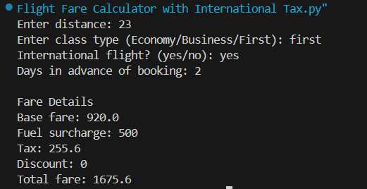
Q20. Smart Vending Machine with Wallet System
Function vending_machine(item, amount_paid, wallet_balance):
Items stored in dict with stock + price.
If sufficient → dispense + return change.
Update wallet balance.
If stock = 0 → suggest alternative item.
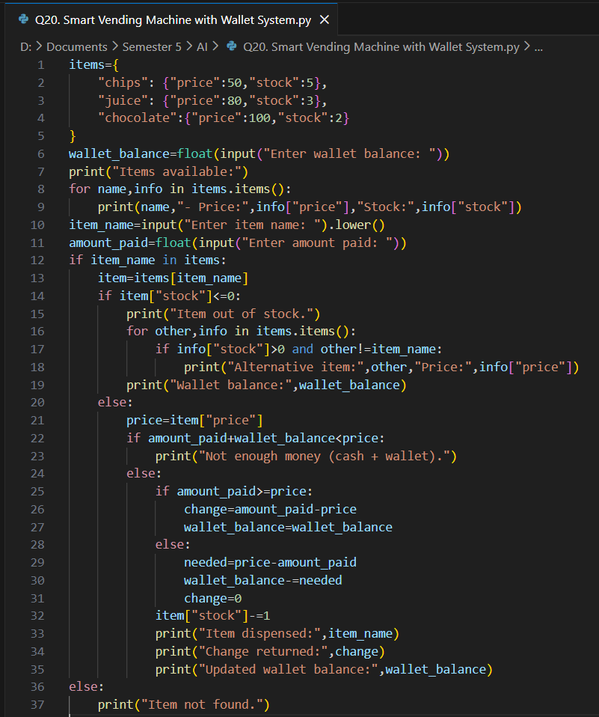
Output:
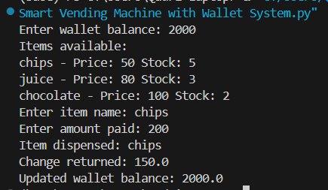

Lab 5
Q21: Create a `BankAccount` class that represents a bank account. It should have attributes for account number, account holder name, and balance. Include methods to deposit, withdraw, and display balance. Ensure withdrawals cannot exceed the available balance.
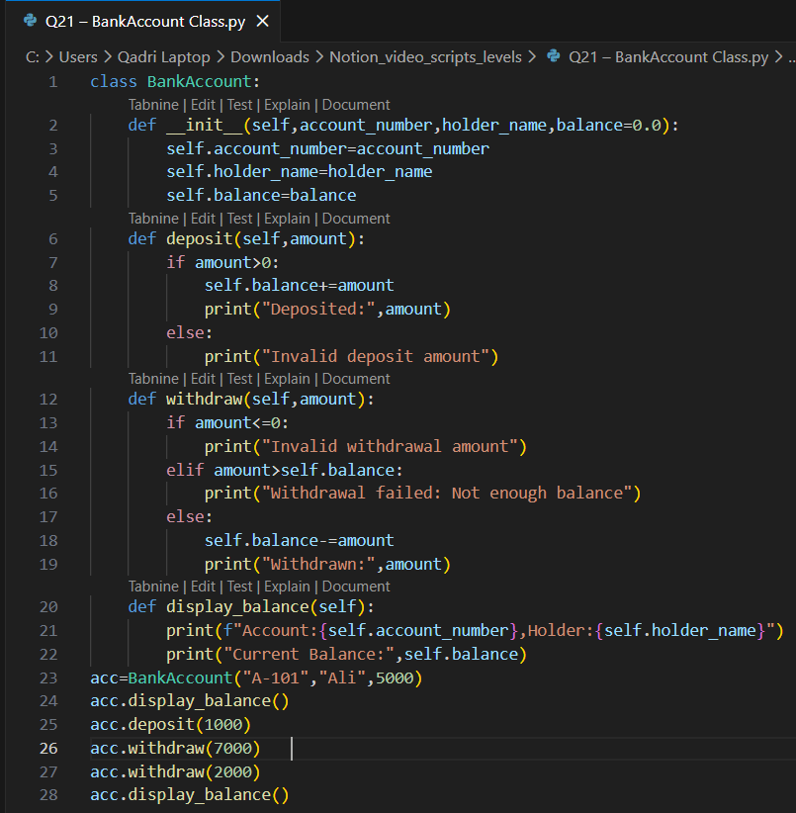
Output:
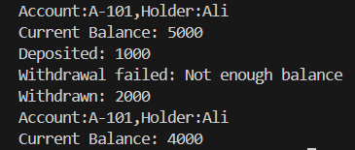
Q22: Design a `Book` class with attributes like title, author, ISBN, and availability status. Create a `Library` class that can add books, search for books by title/author, check out books, and return books. Track which books are currently available.
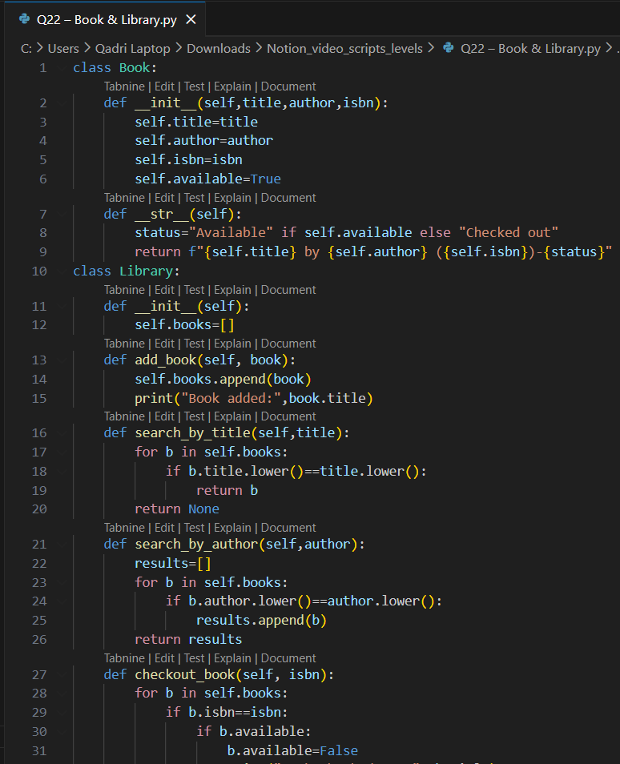
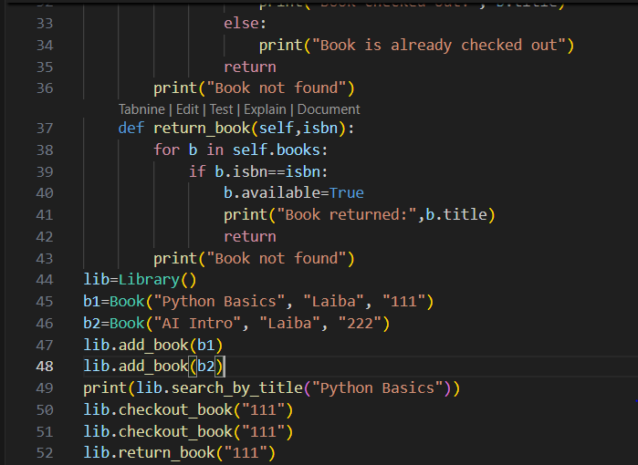
Output:
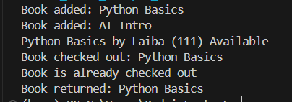
Q23: Create a `Student` class with attributes for student ID, name, and a list of grades. Implement methods to add grades, calculate average grade, and determine the letter grade (A, B, C, etc.). Add a method to display student information with their performance summary.
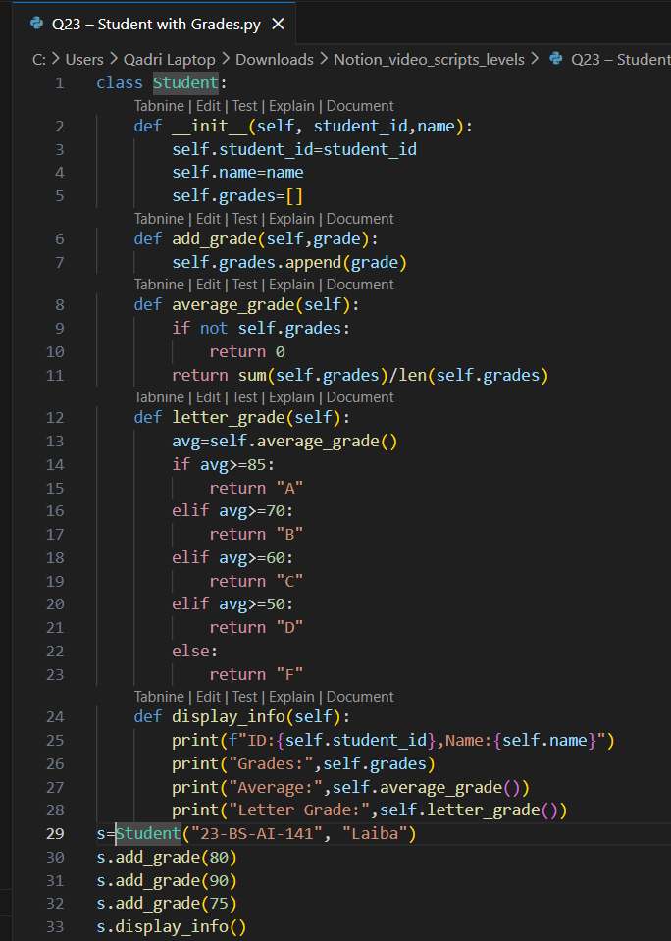
Output:
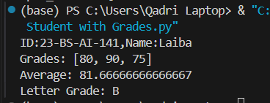
Q24: Design a `MenuItem` class for food items (name, price, category) and an `Order` class that can add multiple items, calculate total cost, apply discounts, and generate receipts. Include tax calculation functionality.
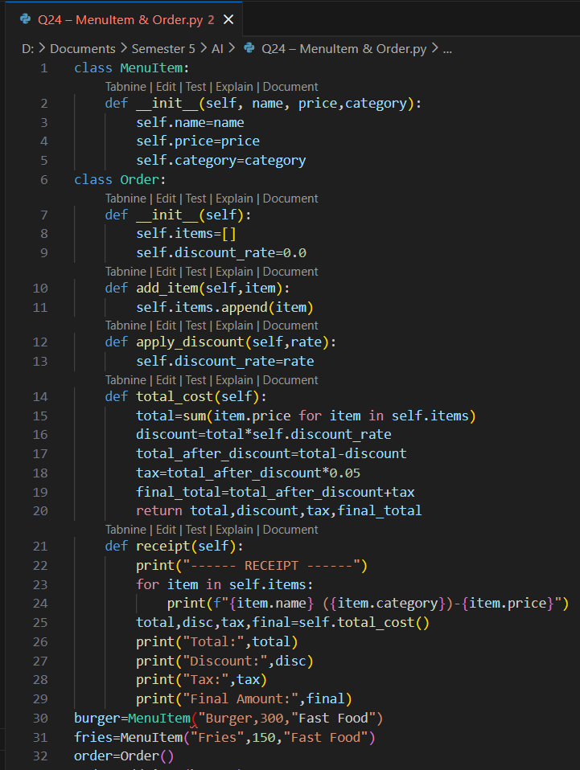
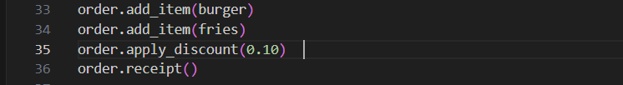
Output:
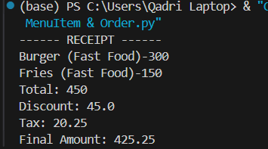
Q25: Create classes for `Vehicle` (base class) and derived classes `Car`, `Motorcycle`, and `Truck`. Each vehicle should have attributes like license plate, model, rental price per day, and availability. Implement a system to rent vehicles and calculate rental costs.
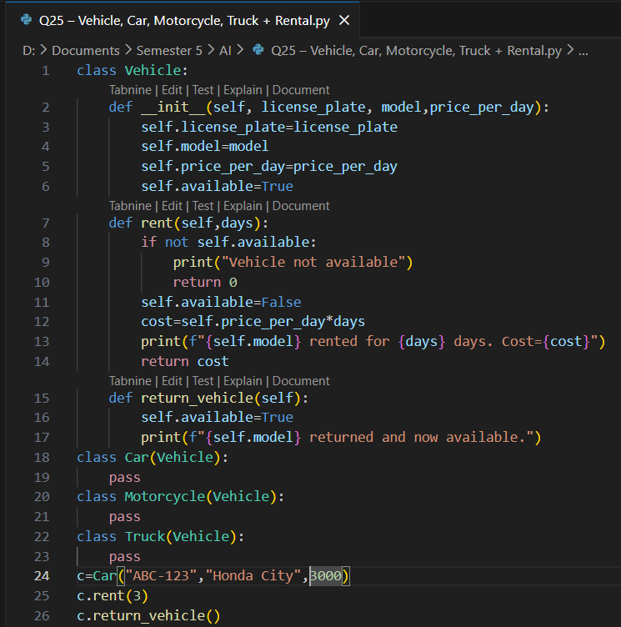
Output:
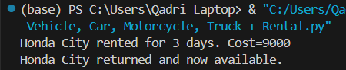

Lab 6
Q26: Design an `Employee` class with attributes for employee ID, name, position, and salary. Create methods to calculate monthly salary, annual salary, and apply raises. Include functionality to track employee details and employment duration.
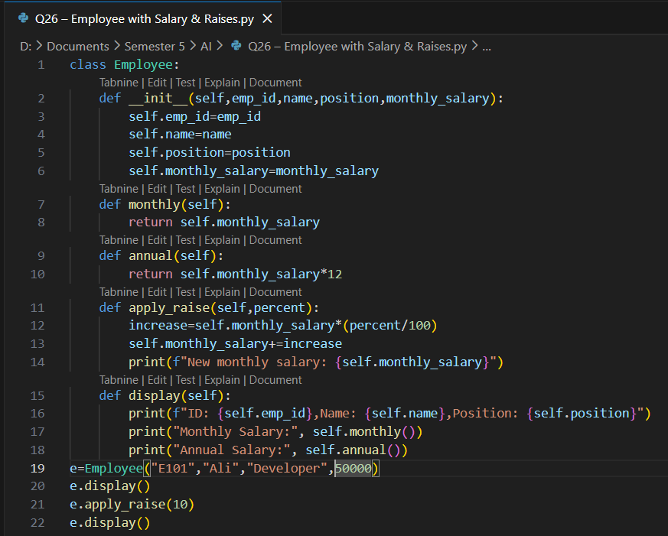
Output:
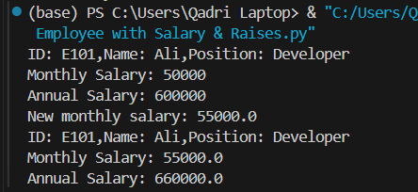
Q27: Create a `Product` class with attributes for product ID, name, price, and stock quantity. Design a `ShoppingCart` class that can add products, remove products, calculate total cost, and handle checkout process while updating inventory.
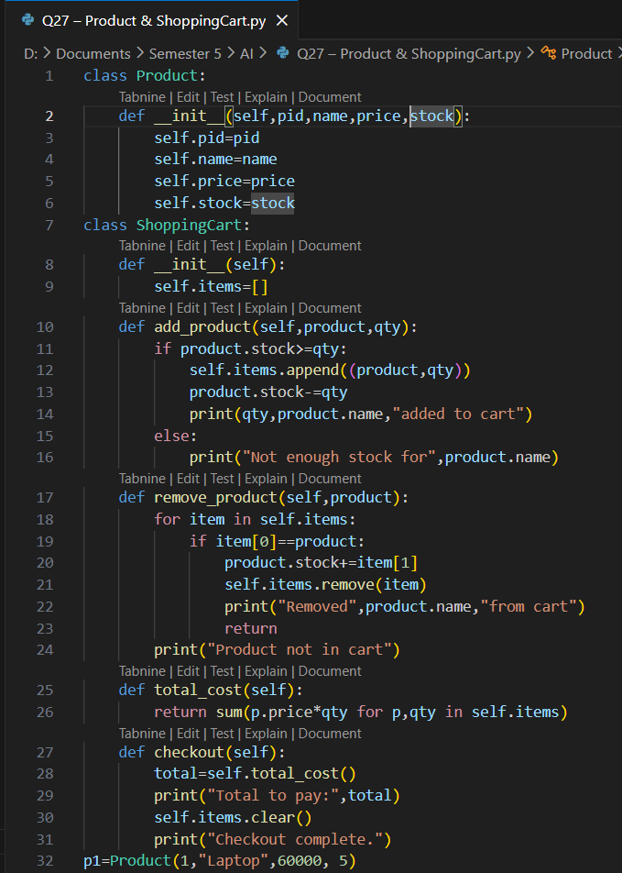
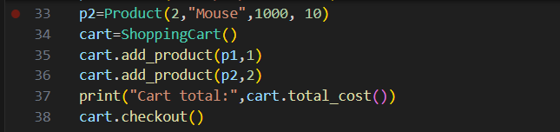
Output:
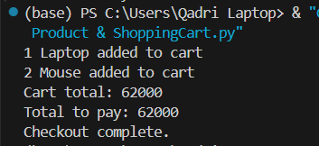
Q28: Design a `Patient` class to store patient information (ID, name, age, medical history) and an `Appointment` class to manage doctor appointments. Include functionality to schedule, cancel, and view appointments.
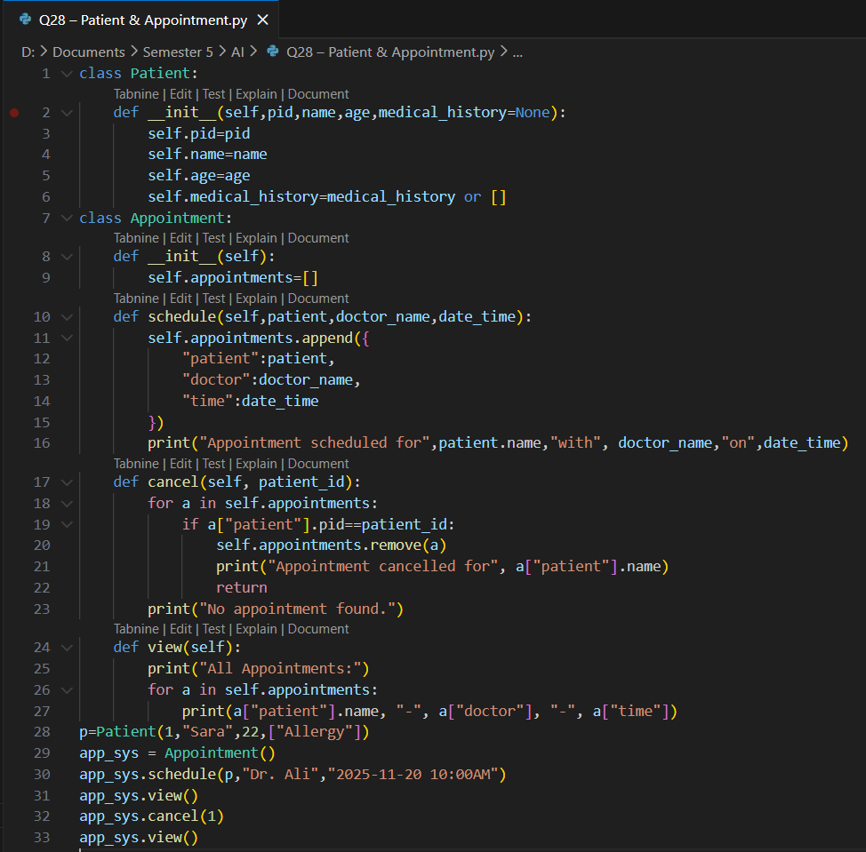
Output:
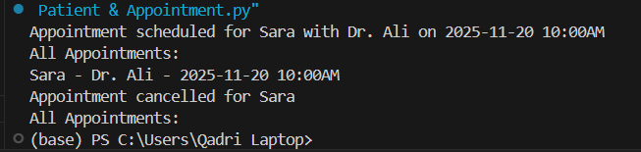
Q29: Create a `User` class for a social media platform with attributes for username, email, friends list, and posts. Implement methods to add friends, create posts, and display user timeline. Include privacy settings for posts.
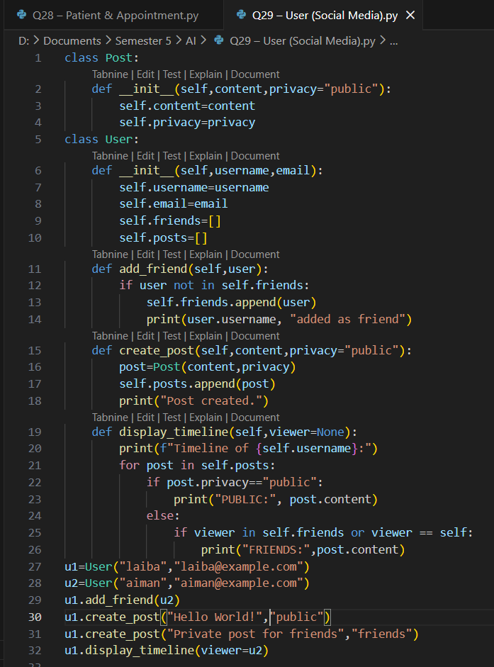
Output:
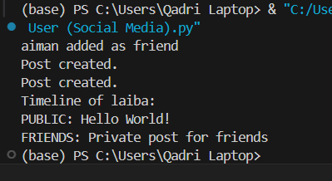
Q30: Design a `Room` class with room number, type (single/double/suite), price, and availability. Create a `Booking` class to handle room reservations, check-in/check-out dates, and calculate total stay cost.
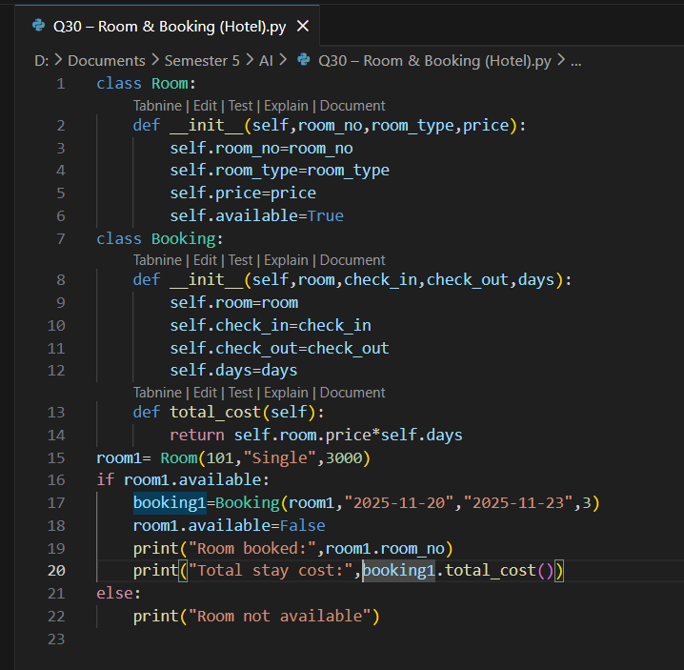
Output:
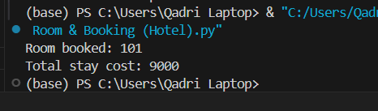

Lab 7
Q31: Create `Course` classes (with code, name, credits, capacity) and a `Student` class that can register for courses. Implement functionality to check for schedule conflicts and ensure students don't exceed credit limits.
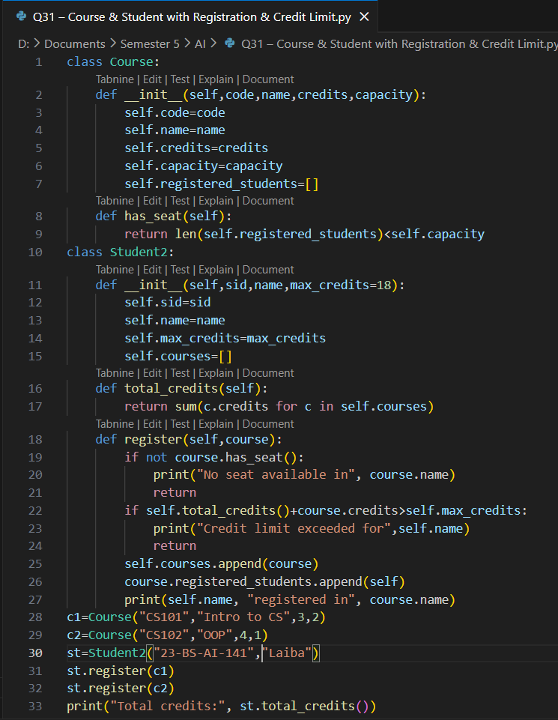
Output:
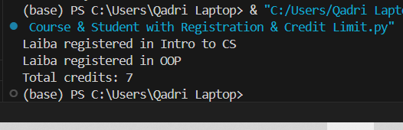
Q32: Design a `Product` class for items in inventory (ID, name, quantity, price, supplier) and an `Inventory` class to track stock levels, add new products, update quantities, and generate low-stock alerts.
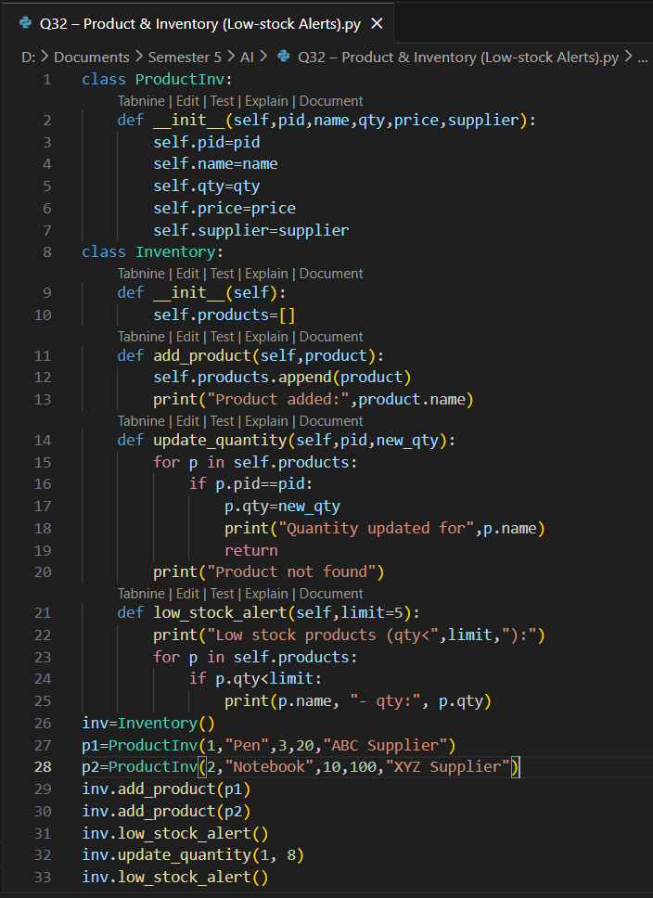
Output:
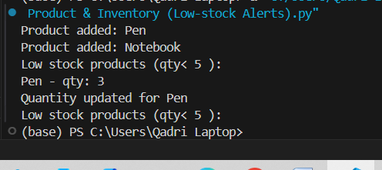
Q33: Create `Movie` classes (title, genre, duration, showtimes) and a `Theater` class with seating arrangement. Implement a booking system that reserves seats and calculates ticket prices with different categories (standard, premium).
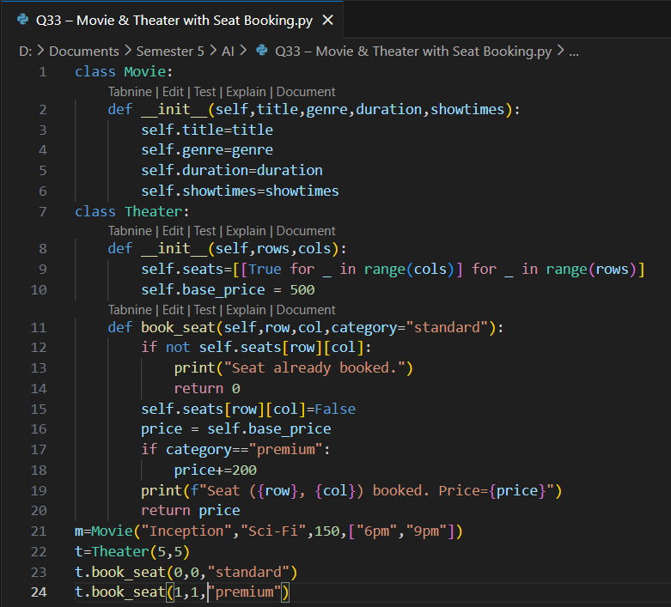
Output:
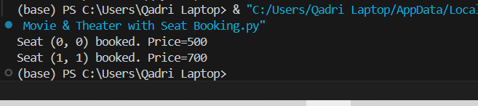
Q34: Design a `Member` class with personal details, membership type (basic/premium), and attendance records. Create a `Trainer` class and a system to schedule training sessions between members and trainers.
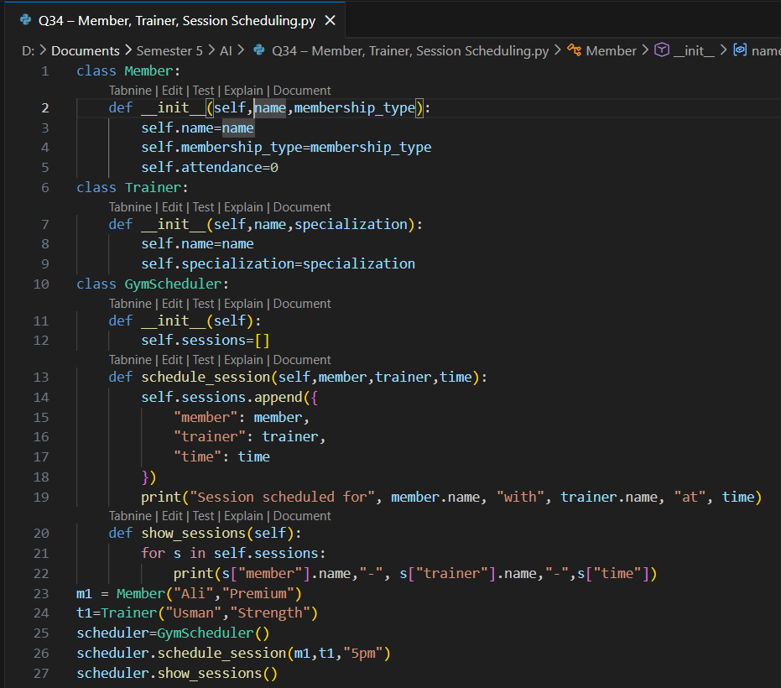
Output:
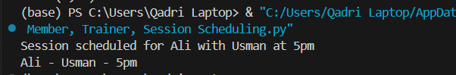
Q35: Extend the bank account system to include `SavingsAccount` and `CheckingAccount` classes with different interest rates and withdrawal rules. Implement fund transfer between accounts.
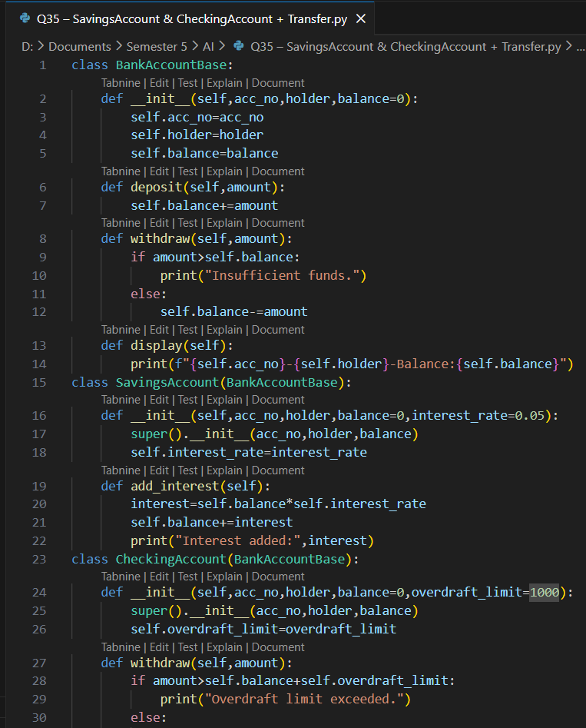
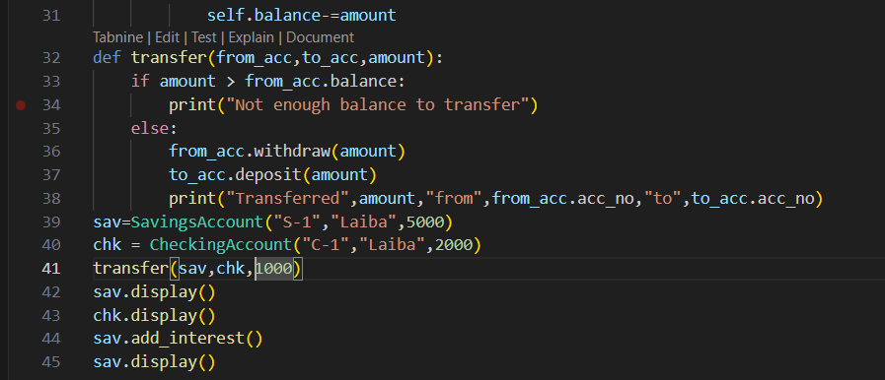
Output:
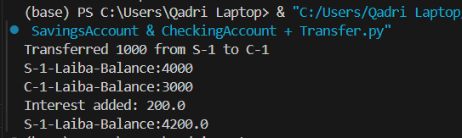

Lab 8
Q36: Create a `Pizza` class with size, crust type, and toppings. Design an ordering system that calculates prices based on selections and allows custom pizza creation with various topping combinations.
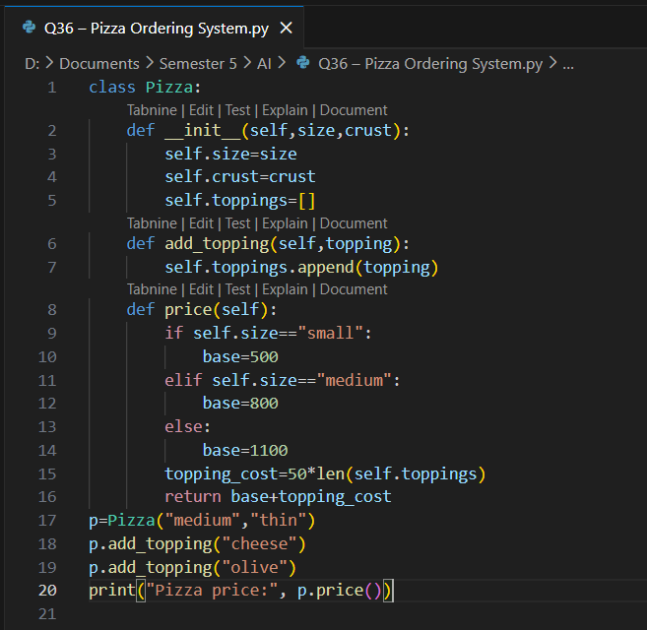
Ouput:
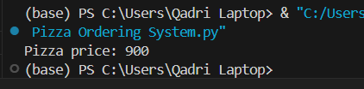
Q37: Design classes for `Car` (model, year, color, price) and `CarManufacturer` that can produce different car models with various features. Include quality control checks and production tracking.
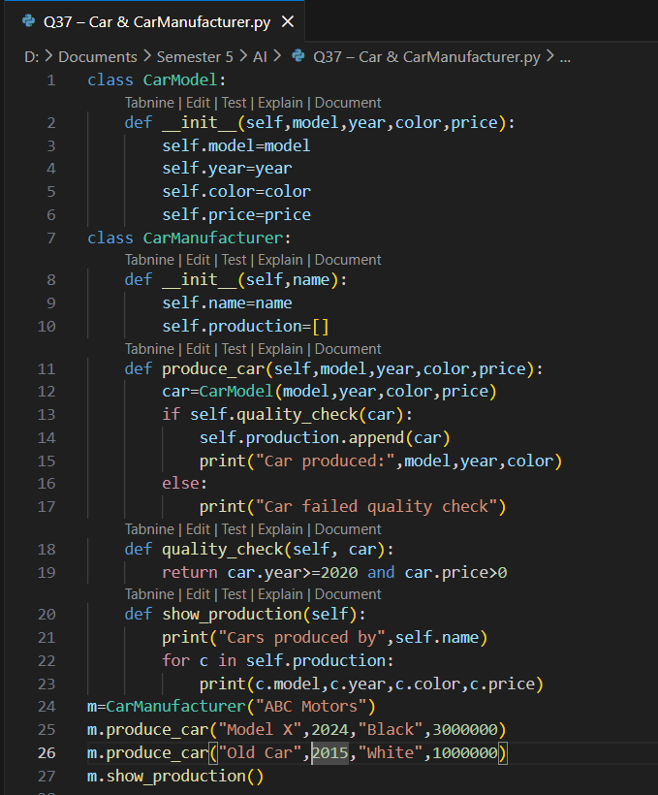
Output:
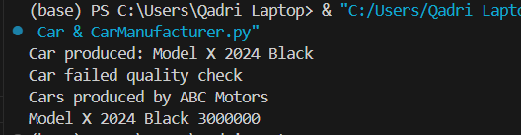
Q38: Create `Teacher` and `Student` classes, and a `Classroom` class that manages assignments, grades, and attendance. Implement functionality to track student performance and generate class reports.
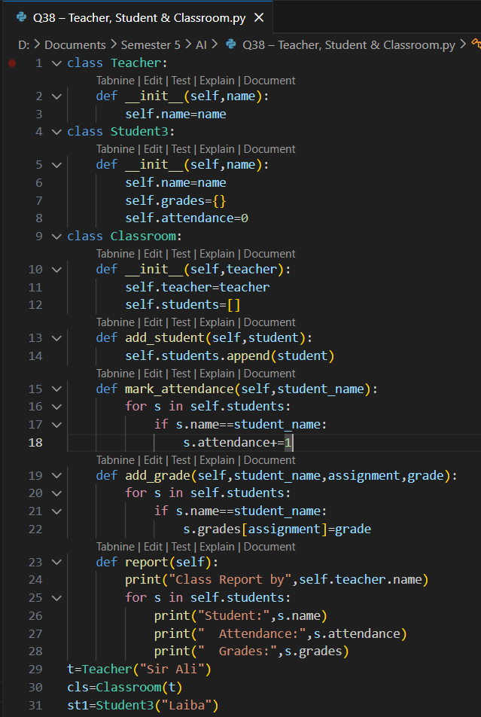
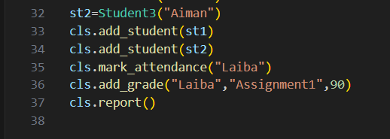
Output:
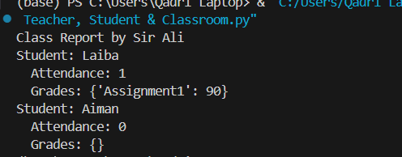
Q39: Design `Flight` classes (flight number, destination, departure time, capacity) and a `Passenger` class. Create a booking system that reserves seats and manages passenger manifests.
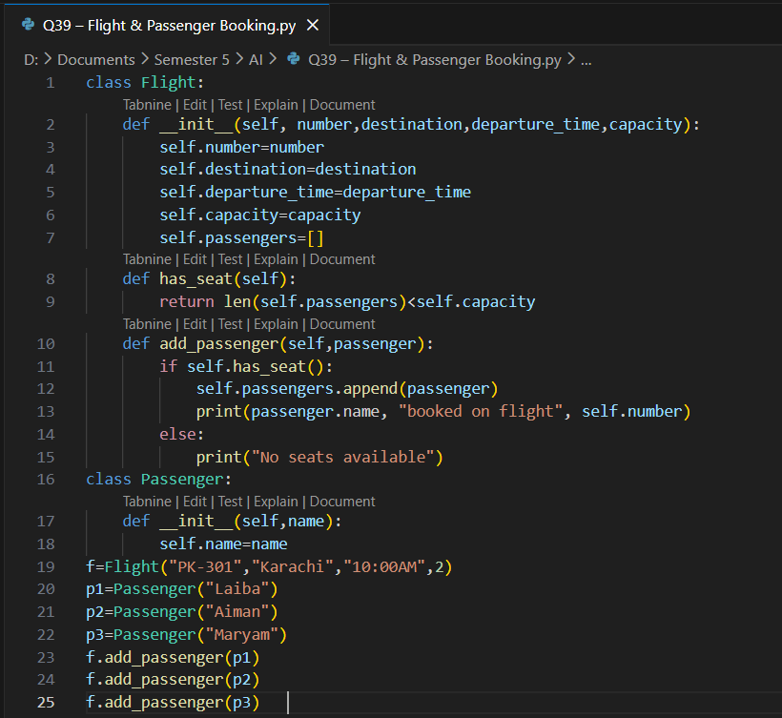
Output:
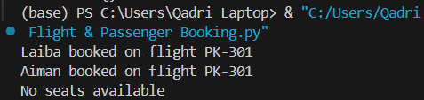
Q40: Create classes for `SmartDevice` (base class) and specific devices like `SmartLight`, `Thermostat`, and `SecurityCamera`. Implement a `SmartHome` class that can control all devices and create automation routines.
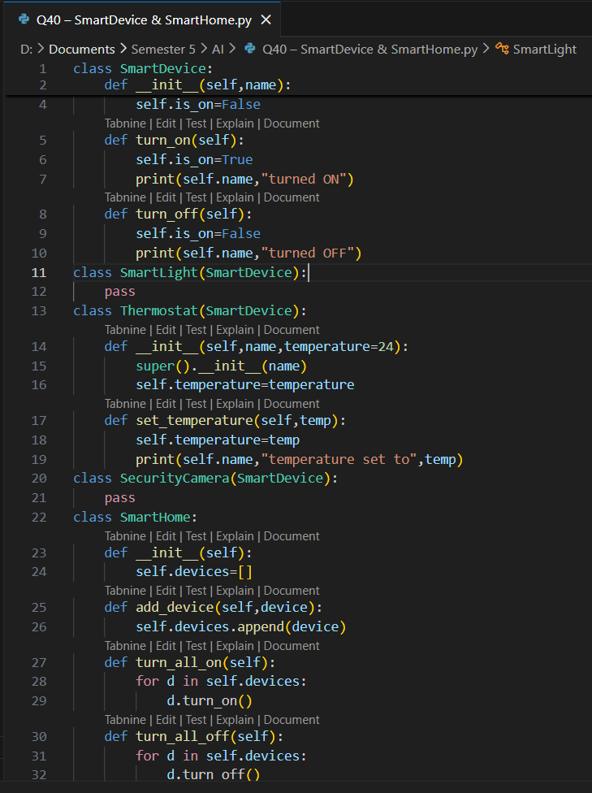
Output:
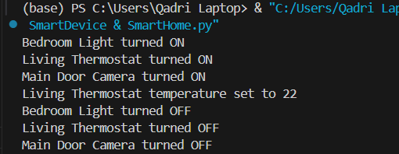

Lab 9
Q41: A weather station records temperatures (°C) for 7 days:
[21.1, 23.4, 19.8, 25.0, 26.5, 24.1, 22.0]
Task:
- Convert the list into a NumPy array
- Find:
  - Average temperature
  - Maximum and minimum temperature
  - Temperature difference (range)
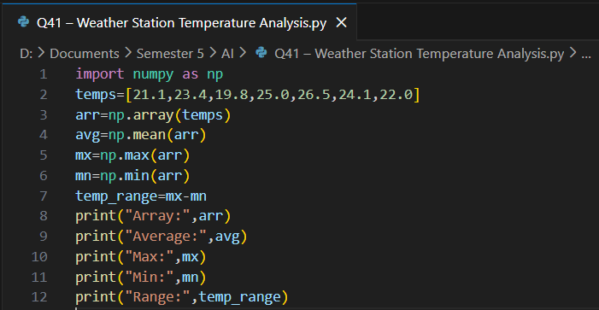
Output:
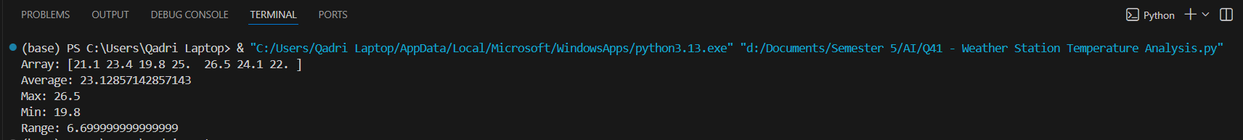
Q42: A fruit store records daily sales of apples for 4 weeks:
Week 1: [12, 15, 14, 10, 9, 8, 7]
Week 2: [11, 12, 13, 9, 5, 8, 6]
Week 3: [7, 9, 12, 10, 11, 13, 12]
Week 4: [10, 11, 12, 7, 8, 9, 11]
Task:
- Create a 4×7 NumPy array
- Find weekly totals
- Find the highest sale day (index only)
- Find the week with the most sales
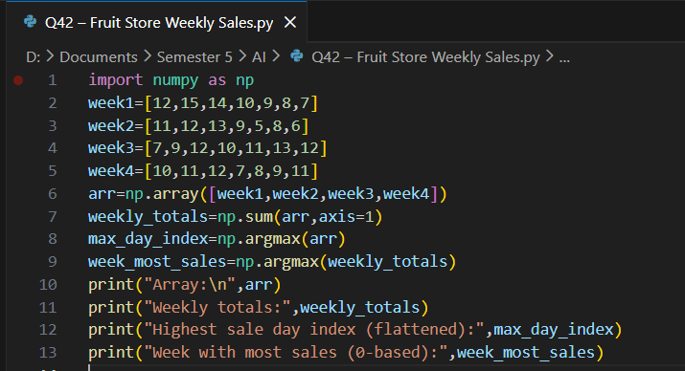
Output:
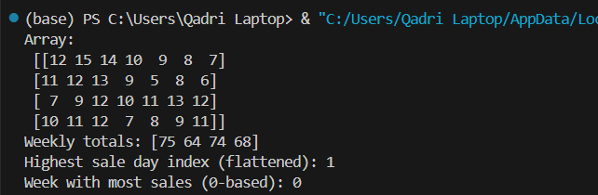
Q43: Students received marks in a test:
[56, 78, 45, 90, 88, 76, 59, 62]
Task:
- Convert to NumPy array
- Add 5 bonus marks to every student using broadcasting
- Count how many students now scored > 60
- Find the median and standard deviation
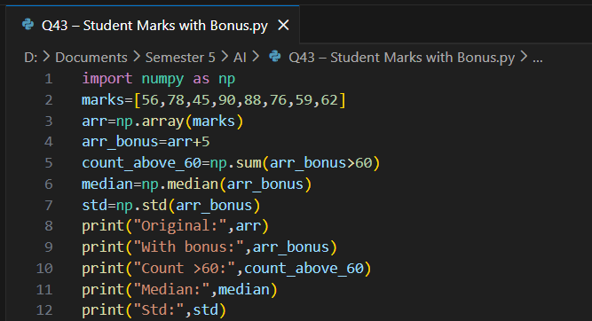
Output:
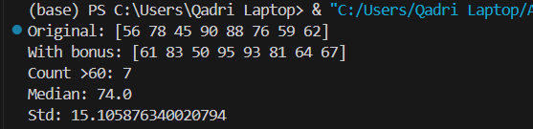
Q44: A smartwatch stores daily step-counts for a user for 30 days.
Task:
- Generate a random NumPy array of shape (30,) with values between 2000–15000
- Reshape into a 5×6 matrix
- Find:
  - Weekly average steps
  - Day with maximum steps
  - Number of days user crossed 10,000 steps
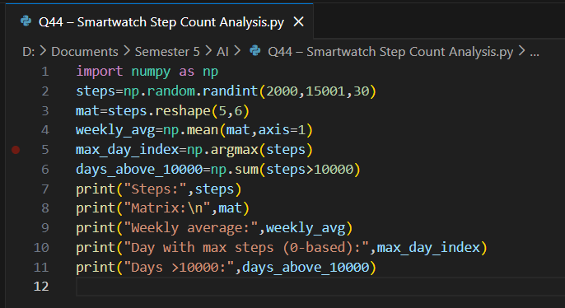
Output:
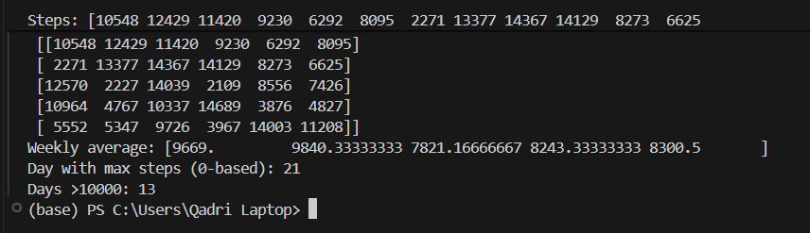
Q45: Heart rate readings (in BPM) for 10 patients recorded 4 times per day:
- Use array shape = (10, 4)
Task:
- Create an integer array using np.random.randint(60,150,(10,4))
- For each patient:
  - Compute daily average
  - Identify abnormal readings > 120
- For all patients:
  - Compute overall maximum and minimum
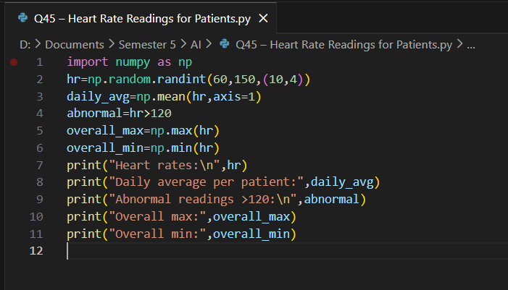
Output:
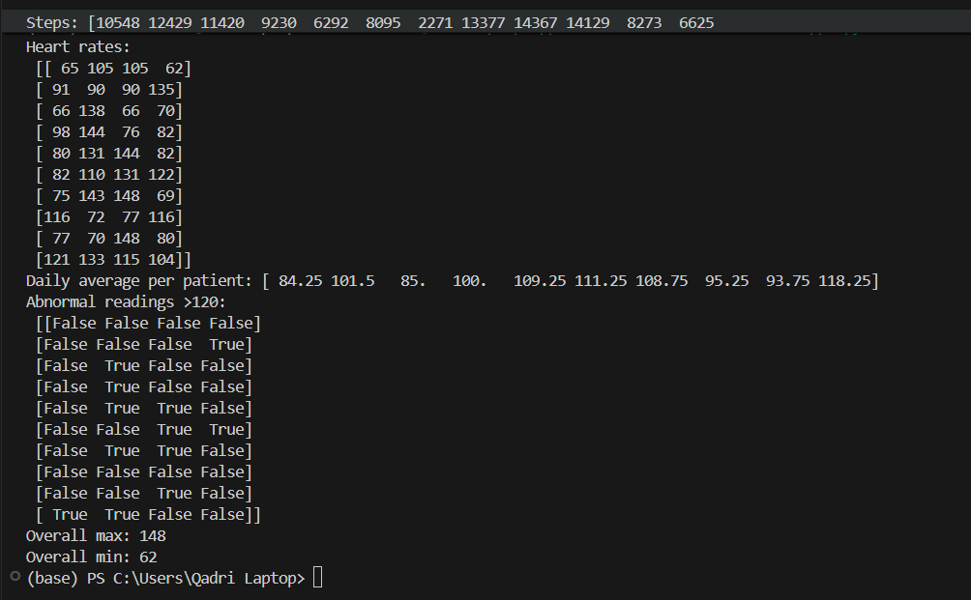

Lab 10
Q46: Two branches of a store record monthly sales (in thousands):
Branch A: [122, 135, 150, 160, 155, 140]
Branch B: [110, 130, 148, 165, 158, 145]
Task:
- Compute difference between branches
- Calculate:
  - Average monthly sales of each branch
  - Which branch performed better overall?
- Compute correlation between A and B
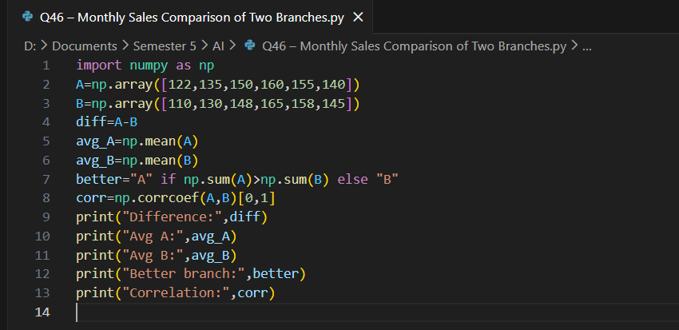
Output:
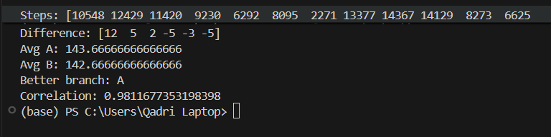
Q47: Given a 4×4 grayscale image:
[[100, 120, 130, 90 ],
[80 , 110, 140, 100],
[70 , 90 , 120, 130],
[110, 140, 150, 160]]
Task:
- Convert to NumPy array
- Normalize pixel values (0–1)
- Apply a transformation: new_pixel = pixel * 1.2
- Clip all values > 255
- Compute average brightness before & after transformation
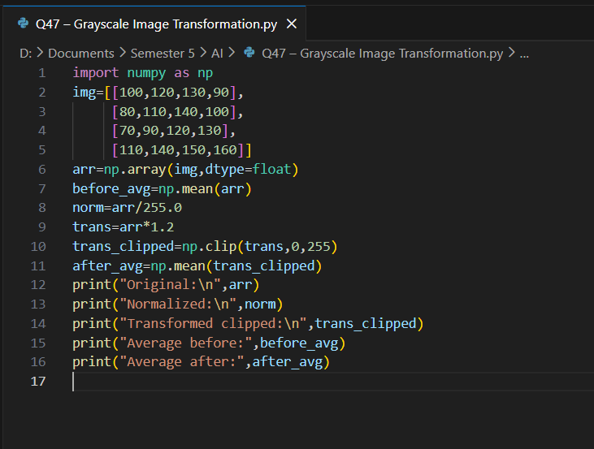
Output:
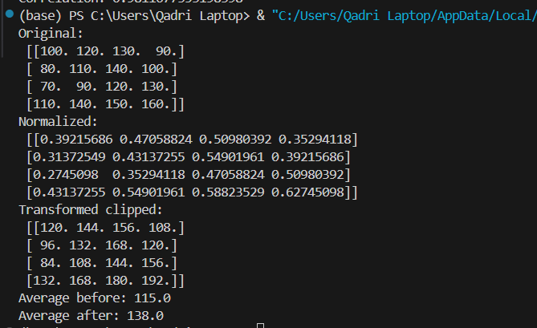
Q48: Dataset contains 100 samples with 4 features each.
Task:
- Generate a 100×4 matrix with values 1–100
- Standardize the dataset using:
- x_scaled = (x - mean) / std
- Perform:
  - Column-wise mean (should be ≈ 0)
  - Column-wise variance (should be ≈ 1)
Verify results using NumPy functions
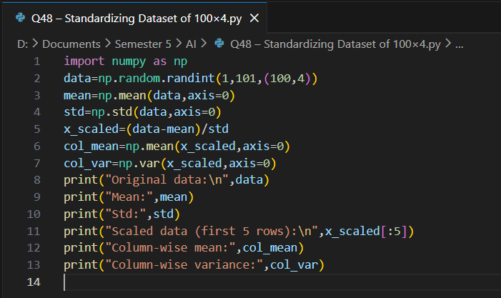
Output:
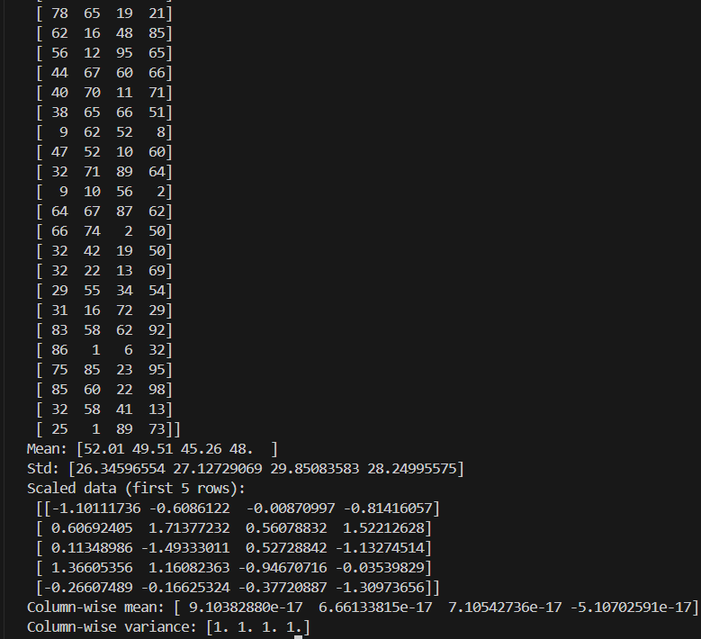
Q49: Simulate traffic density (cars per minute) recorded by 6 sensors over 24 hours.
Task:
- Generate array shape (24, 6)
- Find hourly average
- Identify the busiest sensor (highest total density)
- Apply a threshold:
  - Replace all values above 50 with 50 (traffic cap)
- Compute energy usage:
energy = Σ(sensor_density × 0.5)
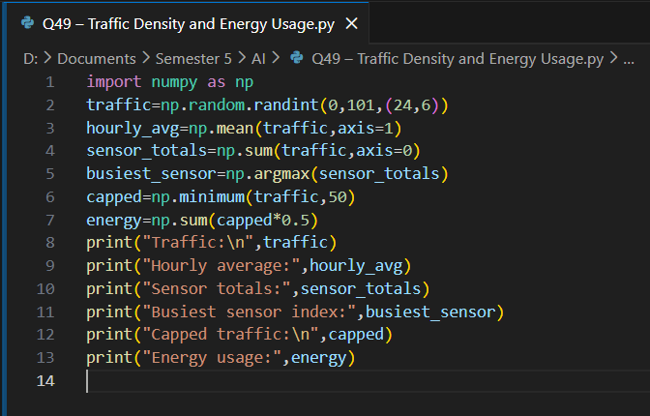
Output:
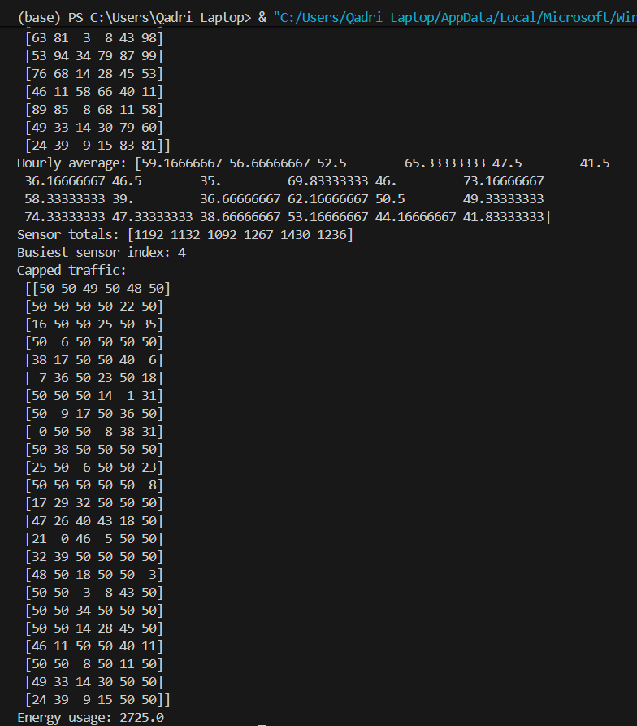
Q50: You are simulating forces in a mechanical system.
Force vectors applied to 5 components:
F = [[5,2,1],
[3,1,4],
[6,3,2],
[4,2,5],
[7,1,3]]
Transformation matrix:
T = [[2,1,0],
[1,3,1],
[0,2,2]]
Task:
- Compute transformed forces: F_new = F × T
- Compute magnitude of each force vector
- Identify the component experiencing highest transformed force
- Perform eigenvalue decomposition of T
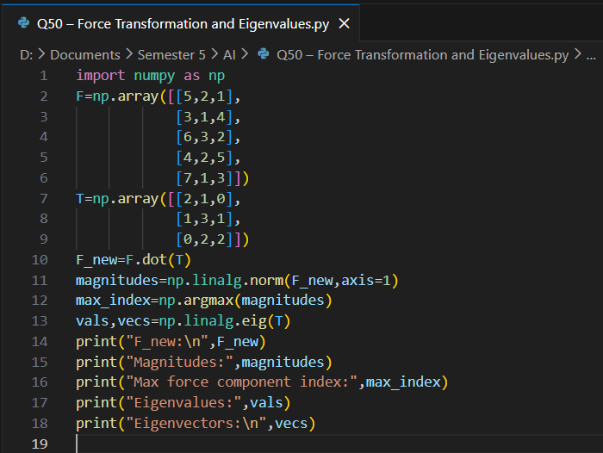
Output:
